Lab Assessment-10

Q)

import java.util.*;

class Student {

String name;

String stu_id;

int score;

public Student() {

this(" ", " ", 0);

}

public Student(String initName, String initId, int initScore) {

name = initName;

stu_id = initId;

score = initScore;

}

}

public class Main {

public static void main(String[] args) {

Scanner in = new Scanner(System.in);

System.out.println("Input number of students:");

int n = Integer.parseInt(in.nextLine().trim());

System.out.println("Input Student Name, ID, Score:");

Student stu = new Student();

Student max = new Student();

Student min = new Student(" ", " ", 100);

for (int i = 0; i < n; i ++) {

stu.name = in.next();

stu.stu_id = in.next();

stu.score = in.nextInt();

if (max.score < stu.score) {

max.name = stu.name;

max.stu_id = stu.stu_id;

max.score = stu.score;

}

if (min.score > stu.score) {

min.name = stu.name;

min.stu_id = stu.stu_id;

min.score = stu.score;

}

}

System.out.println("name, ID of the highest score and the lowest score:");

System.out.println(max.name + " " + max.stu_id);

System.out.println(min.name + " " + min.stu_id);

in.close();

}

}

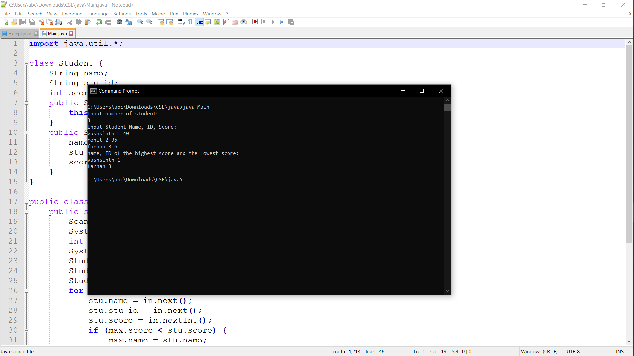

Q)

package serializationdemo;

import java.io.*;

public class EmployeeSerialDemo {

public static void main(String[] args) {

Employee c = new Employee("Suresh", "E123"); // 2

File outFile = new File("empSerial.ser");

try {

FileOutputStream fs = new FileOutputStream(outFile);

ObjectOutputStream os = new ObjectOutputStream(fs);

os.writeObject(c); // 3

os.close();

} catch (Exception e) {

e.printStackTrace();

}

}

}